Omnipod and Libre 2

This document is produced by the Diabetes Leicestershire Partnership Trust. The policy itself is generated by health professionals and is guidance to Schools / Academies and Educational establishments specifically for supporting Pupils with Diabetic medical needs. The document can be separated and used in line with advice from the child’s diabetes team. Pages 18, 20 and 41 in particular should be displayed for quick reference during urgent / emergency situations. We would like to acknowledge input from professional bodies and services within Leicestershire County Council, to include City and Rutland. The establishment’s senior leadership team should agree healthcare plans that are signed off by the Head teacher and SENCO as current and valid.
An internal annual review is required for individuals with any Health Care Plans.
Please note additional information is available in the appendices section listed on the schools website www.leicestershiretradedservices.org.uk relating to other specific medical conditions and healthcare support plans for individual needs.

- Introduction

1.1 This guidance is specifically to address the issue of the management of Type 1 Diabetes (T1D) in children and young people in non-health settings or early year’s provision in Schools. The management of T1D includes testing blood glucose levels, recording and interpreting the results, counting the carbohydrate content of their meal and calculating and administration of insulin via injection or insulin pump.

1.2 Incidence of Type 1 Diabetes
The UK has the fifth highest rate of type 1 diabetes in children. There are approximately 31,500 children and young people in the UK with this condition with approximately 400 children of school age living in Leicestershire County, City and Rutland.

1.3 Insulin Regimens

It is now accepted that life expectancy is improved and the risk of significant long term complications reduced when a strict routine of self-care and treatment is followed. Injection / Pump regimens allow greater flexibility and promote the independence of the child. The regimen, incorporating increased blood glucose testing, insulin dose adjustment and the increased frequency of the use of insulin injections or the use of continuous insulin pump therapy means children will need to adhere to these care activities whilst they are in educational settings.

1.4 Support in educational settings

It is important that children and young people with diabetes are properly supported in the school settings that they attend. School settings should ensure T1D are cared for by staff that have had diabetes training and that the training is updated annually. The amount of support required varies from one child to another. This may be awareness of their independent management of their condition, through supervision to significant assistance in the activities. The amount of support a child requires does not necessarily decrease with age and it is important that the care plan is reviewed regularly to reflect the child’s individual needs. Good support at school in the form of knowledgeable, understanding staff, robust care plans and processes in place will help the child to ensure they achieve good diabetes management and control. It is recognised that well controlled blood glucose levels positively impacts upon the individual’s academic ability and thus good support plays an important role in achieving this.
Advice can be obtained at any time during the school day by contacting the Diabetes Specialist Nurses Office based at the Leicester Royal Infirmary on Tel: 0116 258 6796

1.5 Legislation

A child who has been prescribed a drug may legally have it in their possession if they are competent to do so, but passing it to another child for use is an offence.
Members of staff have a legal duty to receive information, instruction and training where support for an individual is required.
A statutory requirement at school for supporting pupils with medical needs was issued by the Department of Education in 2014 and was updated in 2015. This document was hugely driven by Diabetes UK to improve the lives of children with diabetes in Schools. 4

The full document can be accessed: www.gov.uk/government/publications/supporting-pupils-at-school-with-medical-conditions-3 or via the www.leicestershiretradedservices.org.uk under Medication and Management Procedures (appendices).
This legislation is also supported by section 100 of the Children and Families Act 2014 placing duty of care to establishment’s senior management team. *This means to take account of the guidance and to carefully consider it. Having done so, there would need to be a good reason to justify none compliance with it*
Pupils within education with medical conditions should be properly supported so that they have full access to education, including school trips and physical education.
Special educational needs and disability (SEND) code of practice 4 explains the duties under part 3 of the Childrens and Families Act 2014 for those pupils who have diagnosed medical conditions.
Some children with Type 1 Diabetes will have a statement of special educational needs/Education, Health and Care plan in place in order to meet their needs. Every child’s experience of Type 1 Diabetes is different and the level of support required depends on the individual child. If a child has a statement/EHC plan, their individual health care plan must link to that. The SENCO will need to input into the IHP, recognising how diabetes affects their learning.

1.6 The role of the Paediatric Diabetes Team – at diagnosis

The Children’s Diabetes Team provide ongoing education and support to children and their families from diagnosis until they are transitioned to adult services between the ages of 16 to 18 years of age. When a school age child is newly diagnosed the diabetes specialist nurse will make contact with school to arrange to visit school, provide training and prepare a care plan. This all needs to be in place before the child can return to school.

1.7 On-going Training

Schools who have children with T1D are required to update their training yearly, by attending a training session held at the Leicester Royal Infirmary, and reviewing the care plan with parents. The training is facilitated by the Paediatric Diabetes Specialist Nurses. Details of these training sessions are included in this pack. Booking is essential and it is advisable to book well in advance as there is a high demand for training. This training is free however a £50 charge will be invoiced per person for non – attendance or where 48 hours cancellation notice is not provided by the school. It is not possible for a Diabetes Nurse to visit individual schools to provide update training or to complete individual care plans. Once care plans have been completed by school then a copy can be given to the parents to share with the diabetes team. We are available for telephone support -0116 258 6796.

INDIVIDUAL HEALTH CARE PLAN
Name:

Insert Photo here
DOB:
School/College:
Year Group:

Date of Plan:
Review Date:

FAMILY CONTACT INFORMATION
Name
Relationship | Mother
Telephone number | Home:  Work: | Mobile:
Email
Name
Relationship | Father
Telephone number | Home:  Work: | Mobile:
Email

OTHER ESSENTIAL CONTACT INFORMATION
JOB TITLE | NAME | TELEPHONE NUMBER
Paediatric Diabetes Nurse
Class Teacher
LSA
SEN Co-ordinator
Head Teacher

DESCRIPTION OF CONDITION AND DETAILS OF INDIVIDUAL TREATMENT
- This young person has Type 1 Diabetes
- This young person manages his condition with insulin via a continuous insulin infusion pump.
- Insulin is required as follows:

Continuous subcutaneous insulin infusion (CSII)
- This insulin pump is working continuously 24/7
- Blood glucose levels need to be tested throughout each day.
- This young person will need to attend clinic appointments to review their diabetes.
- Appointments are every 3 months as a minimum, but may be more frequent.
- In accordance with National Guidance, school staff should be released to attend diabetes training sessions

DIABETES GUIDANCE
USE OF LIBRE FLASH GLUCOSE MONITOR FOR
Insulin Pumps

Usual times to check CGM are:
Before meals
Before/ After P.E/Swimming
Other times – please state: illness

Guidance
- A parent or a carer over 18years old is responsible for supervising, managing, assisting the child/young person in use of the Libre system and in interpreting the results.

- A finger prick blood glucose test is required in place of the Libre continuous glucose monitor (CGM) reading at the following times:
- Hyperglycaemia >14mmol/l (blood ketone testing also required)
- During illness
- Hypoglycaemia <3.9mmol/l
- When symptoms do not match the Libre system recordings
Libre Navigation
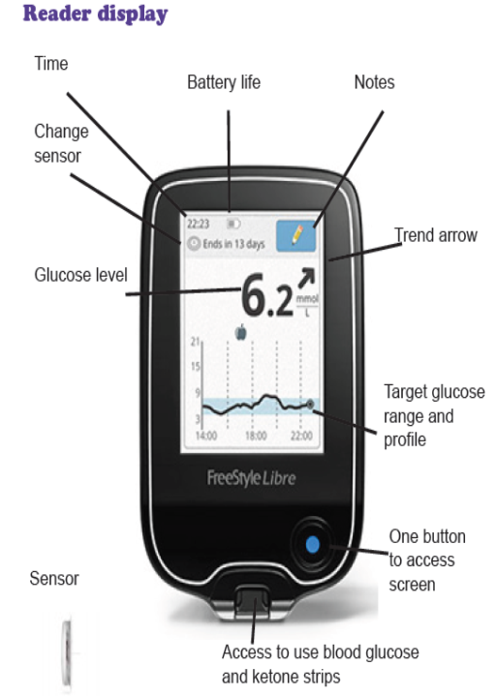
Sensor glucose readings from the continuous glucose monitor (CGM) along with rate of change arrows can be seen permanently on the Libre
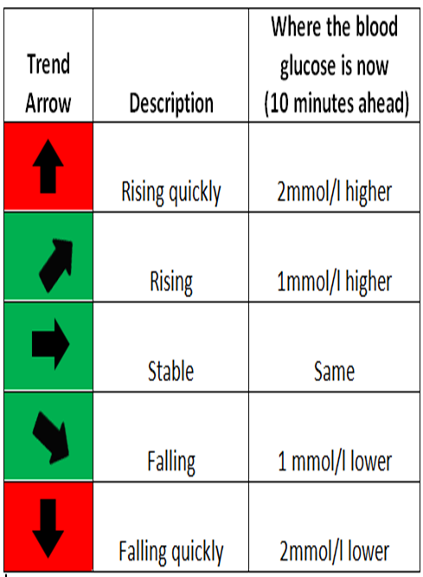

How to scan to get the Libre CGM reading

- Press and hold the blue button on the bottom right of the meter for two seconds
- Touch Check Glucose on the screen

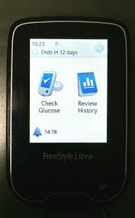
- Swipe the Libre across the sensor

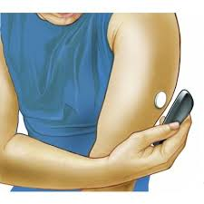
Bolus Algorithm - Simple
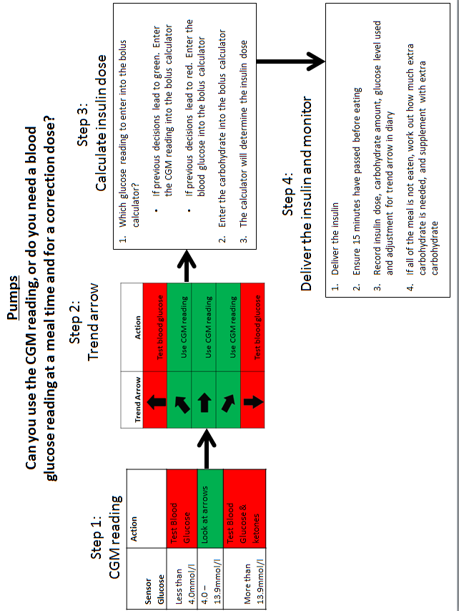
INSULIN ADMINISTRATION

Insulin dose varies depending on what is being eaten.
- An area of privacy and safety should be provided to administer insulin injections.
Insulin Name: | Novorapid

At meal times, the child or young person requires variable amounts of quick acting insulin, depending on how much they eat; Insulin to Carbohydrate Ratio (ICR) and on what their blood glucose level is; Insulin Sensitivity Factor (ISF or often called a ‘correction’)
Insulin to Carbohydrate Ratio: | This is calculated by the pump
Insulin Sensitivity Factor: | This is calculated by the pump

STORAGE OF INSULIN INJECTIONS AND BLOOD GLUCOSE KIT
Spare Insulin to be kept in secure place in the medical room fridge
Blood glucose monitoring kit to be carried on person
All sharps to be disposed of in a sharps box

SUGGESTED DAILY ROUTINE
 | Time | Notes
Arrive School |  | Not required
Morning Break |  | Use glucose reading from Libre, give bolus of insulin for any carbs eaten. Allow pump to correct if correction suggested.
Lunch |  | Use glucose reading from Libre, give bolus of insulin for any carbs eaten. Allow pump to correct if correction suggested.
Afternoon Break |  | Use glucose reading from Libre, give bolus of insulin for any carbs eaten. Allow pump to correct if correction suggested.
School Finish |  | Not required
Other |  | Pre and post PE/swimming: take action as per chart below.

PHYSICAL ACTIVITY
Monitor blood glucose before and after PE/ Swimming

ADD PE TABLE HERE

Before P.E.

The child/young person should check their blood glucose or scan with the Libre unless it is straight after lunch.

BG 14 or above & feels unwell. Ketones above 0,6mmol/litre | BG 14 or above  And feels well ketones less than 0.6mmol/litre | - BG 7 or less | - Below 4 mmols/l

- No exercise  - Drink plenty of water  - Ring parent  - Corrective dose of insulin | - Drink plenty of fluids  - Able to exercise | - 10g carbohydrate prior to exercise | - Treat hypo immediately  - Wait 15 minutes  - Once over 4mmols/l can exercise.

They Should then check their blood glucose at the end of the lesson and have a carbohydrate snack to stabilise their blood glucose (e.g. 2 biscuits) no insulin will be required for this.

Management of exercise is individual to each child and therefore a clear plan should be discussed with parents and documented

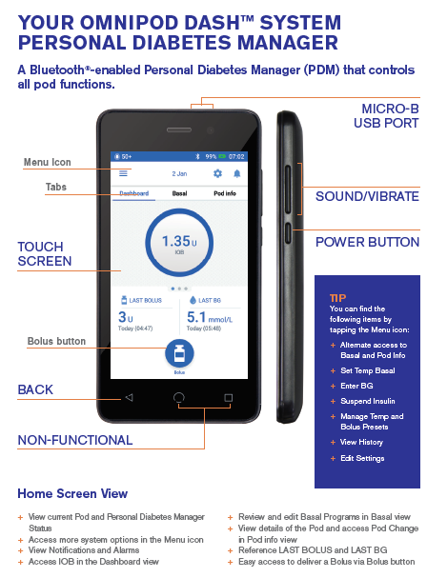

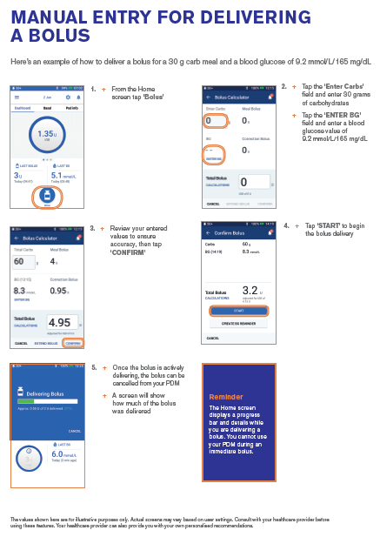

HYPOGLYCAEMIA (LOW BLOOD GLUCOSE) MANAGEMENT
CGM below 4mmol/l MUST test Blood Glucose
Signs and symptoms can include:
Sweating Pallor
Trembling Anxiety
Weakness Headache
Confusion Sleepiness
Slurred speech Blurred Vision
Personality Change Nausea and Vomiting

This young person will show the following symptoms if their blood glucose is low. If any of these symptoms are displayed check blood glucose immediately.
Individual Hypo Symptoms
1
2
3
4

- Do not move the location of this young person to treat a hypo.
- Hypos are described as mild, moderate or severe depending on this young persons ability to treat themself
- The aim is to treat, and restore the glucose level to over 4mmol/L.
- If having a severe hypo and is unable to swallow suspend pump (See end of plan), put child in a safe position and dial 999 for paramedic assistance.

A hypo box should be kept in school. Contents of hypo box should include:
Fast acting glucose choice
Glucogel
Long acting carbohydrate
- All staff must be aware of where the hypo box is kept.
- The hypo box should be taken with Tyler if moving around the school premises.
- It is parent’s responsibility to ensure that the hypo box is adequately stocked.
ALWAYS TREAT THE HYPO THEN CONSIDER WHAT HAS CAUSED IT:
- Too much insulin?
- Not eating enough carbohydrates?
- Missed or delayed meal?
- Intense exercise?
HYPOGLYCAEMIA FLOW CHART
(‘Hypo’ or Low ‘Blood Glucose’)
CGM below 4mmol/l and confirmed with blood glucose

- Excessive Sweating | - Trembling/Shaking | - Feeling Weak or Cold
- Confusion | - Slurred Speech | - Personality/Change
- Pins and Needles | - Nausea and Vomiting | - Paleness
- Anxiety | - Headache | - Sleepiness
- Blurred Vision | - Hunger | - Pounding Heart

Step 1:
Treat immediately with one of the following (or refer to IHCP):
- Lucozade Original x 110ml
- Dextrose tablets x 3
Step 2:
Check the CGM 20 minutes later.
Step 3:
If the CGM is still below 4mmol/L repeat Step 1 and retest

Step 4:
Once glucose is 4mmol/L or above continue with daily regime

Mild Hypo
The child can eat and drink and is cooperative

Step 1: Give GlucoGel® as per IHCP – squeeze 2 tubes gradually between the inner cheeks and the teeth
Step 2: Re-test blood glucose 15 minutes later
Step 3: If glucose is still below 4mmol/L repeat Step 1 and retest blood Glucose a further 20 minutes later.
Step 4: If glucose still <4mmols after 2nd hypo treatment, stop insulin pump and retest BG every 15mins until BG back within target.
Step 5: Once blood glucose is 4mmol/L or above start insulin pump and continue with daily regime

Moderate Hypo
The child is conscious but not cooperative

Severe Hypo
The child is unconscious and/or having a seizure and so unable to swallow
Step 1: Place child in the recovery position.
Step 2: Ensure the airway is open and that the child is breathing.
Step 3: Call 999 and stay with the child while someone waits to direct the ambulance and informs parents.
Step 4: Suspend insulin pump & test BG every 15mins until BG back within target.

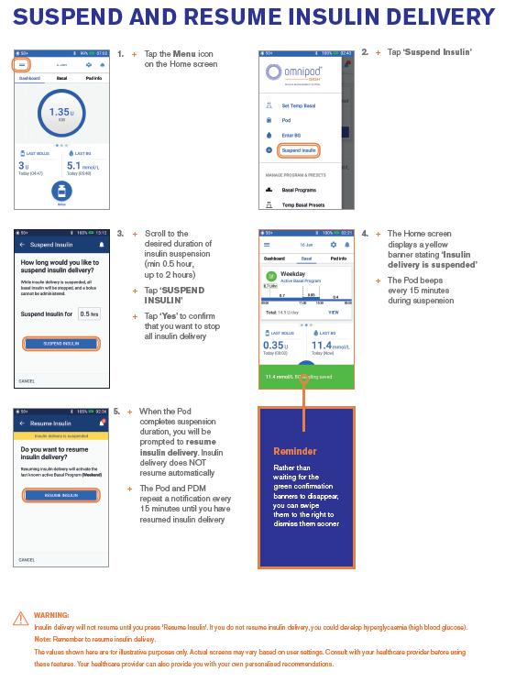

HYPERGLYCAEMIA (HIGH BLOOD GLUCOSE) MANAGEMENT
CGM above 14mmols/L and confirmed with blood glucose test
This student will show the following symptoms if their blood glucose is high. If any of these symptoms are displayed check blood glucose immediately:

Individual Hyperglycaemic Symptoms
1
2
3
4

GENERAL ADVICE WHEN MANAGING HYPERGLYCAEMIA
- If this young person is well there is no need to send him home.
- Parents should be informed that this young person has had high blood glucose levels.
- This young person should be encouraged to drink sugar free fluids.
- This young person should be allowed to use the toilet as needed.
- This young person should not exercise if his blood glucose level is high (above 14mmols)and ketones over 0.6mmol/l.
- This young person should check her ketones. If ketones are above 0.6mmols/L contact parents/carers/Diabetes Home Care
- Consider if there is a problem with the insulin pump :-
- ASSESS:-
- Has a hypo been treated in the last 4hours? If so only give bolus for carbs if eating
Has a bolus been given within the last 90 minutes?
If so, do nothing and retest blood glucose level again in 1 hour.
IF NOT:
- Consider the following: -
Is the pump running?
Is there insulin in the pump?
Is the infusion line leaking or damaged?
Is the needle/ cannula OK?
- CHECK
Check blood glucose level 1-2 hour after ttheir bolus has been given
If blood glucose level is lower than the previous value, no further action is required
- CHANGE
If blood glucose level is equal to or higher than the previous value, contact parents as the cannula may need to be re-sited.

ADVICE FOR HYPERGLYCAEMIA WITH ILLNESS

- If this young person has high blood glucose levels and:
- Ketones > 0.6mmols
- Headaches
- Abdominal Pain
- Nausea or Vomiting

*CONTACT PARENTS IMMEDIATELY*

- The young person needs to be taken home.
- Parents need to monitor blood glucose and ketone levels.
- Extra insulin will be required.
- Parents should contact the diabetes team for advice.

HYPERGLYCAEMIA FLOWCHART
(‘Hyper’ or ‘High blood glucose’)
Step 1: Libre above 14.0mmol/l – check blood glucose

Step 2: If blood glucose 14.0mmol/l or greater test for Ketones

Signs and symptoms can include:
- Excessive thirst | - Passing urine frequently
- Tiredness/Lethargy | - Blurred Vision/Headache
- Nausea and Vomiting | - Abdominal Pain
- Weight Loss | - Changes in Behaviour/Personality

Step 1: Drink sugar free fluids
Step 2: Give a correction dose of insulin, using the bolus advice function
Step 3: Check blood glucose levels 1-2 hours later.

High Blood glucose levels (Over 14mmol/L)
NO KETONES (less than 0.6mmols)

High Blood glucose levels (Over 14mmol/L)
Blood Ketones 0.6 – 1.5mmol/L
Child well and no vomiting
Step 1: Drink sugar free fluids
Step 2: Contact parents/carers/Diabetes Home Care
Step 3: Competent person must correct high blood glucose and ketone levels with insulin pen
Step 4: Check blood glucose and blood ketone levels 1 – 2hourly

Step 1: Contact parents to collect as child SHOULD NOT BE IN SCHOOL.
Step 2: If vomiting and/or having difficulty breathing call 999.
Step 3: Correct high blood glucose and ketone levels with corrective dose of insulin detailed in the IHCP.

High Blood glucose levels (Over 14mmol/L)
Blood Ketones over 1.5mmol/L and/or unwell/vomiting

SUPPLIES TO BE KEPT AT SCHOOL
- 2 x Infusion Sets

- 2 x 2.0ml Cartridges (200 unit/2ml)

- 1 x Sharps Bin

- 1 x 10ml Vial of Quick Acting Insulin – to be kept in the fridge

- 1 x Quick Acting Insulin Pen –to be kept in the fridge

- 10 x Needles - for insulin pen

- 2 x Energizer Ultimate Lithium AA batteries

- 1 x Blood Glucose Meter + 50 strips

- 1 x Ketone Meter - with 5 strips

- Hypoglycaemia Treatment

  - 2 x 25g Glucogel

  - Chosen rapid acting carbohydrate by student e.g.

    - Glucose tablets
    - Lucozade
    - Full sugar fizzy drinks
    - Fruit juice

Warnings

I give permission to the school nurse, trained diabetes personnel, and other designated staff to perform and carry out the diabetes care tasks as outlined by this Diabetes Health Care Plan.
I also consent to the release of the information contained in this Diabetes Health Care Plan to all staff members and other adults who have custodial care of my child and who may need to know this information to maintain my child’s health and safety.

Plan Approved By: | Name | Signature | Date

Young Person

Parents/ Guardian

Diabetes Specialist Dietitian

School Representative

School Nurse

Who is responsible in an Emergency?
- School staff will take the action detailed above
- Parents should attend school when requested to do so

Form completed by:
Form copied to: School, Parents and Notes

